Movie Recommendation System

1. Introduction
In the digital era, the availability of a vast number of movies across multiple platforms has made it difficult for users to decide what to watch. A Movie Recommendation System helps users discover relevant movies by analyzing similarities between movies and suggesting content aligned with user interests. Recommendation systems are widely used by platforms such as Netflix, Amazon Prime, and Disney+ to enhance user experience.
This project focuses on developing a Content-Based Movie Recommendation System using Python and machine learning techniques. The system recommends movies based on the similarity of movie content such as genres and titles.

2. Problem Statement
With thousands of movies available online, users often face confusion and decision fatigue while selecting a movie. Traditional browsing methods are time-consuming and inefficient. There is a need for an intelligent system that can automatically recommend movies similar to a user’s preferred choice.

3. Objectives of the Project
The main objectives of this project are: - To design and implement a movie recommendation system - To analyze movie data and extract meaningful features - To recommend similar movies based on content similarity - To apply machine learning techniques such as TF-IDF and Cosine Similarity - To provide accurate and relevant movie suggestions

4. Scope of the Project
This project demonstrates a basic recommendation system using a single dataset. It is suitable for academic purposes and can be extended to include user ratings, collaborative filtering, and hybrid recommendation approaches in the future.

5. Dataset Description
The dataset used in this project is movies.csv.

Dataset Attributes:
There are many attributes used such as title, budget, genres, cast crew, etc.
The dataset contains sufficient information to build a content-based recommendation system.

6. Tools and Technologies Used
- Programming Language: Python
- Development Environment: Google Colab
- Libraries Used:
  - Pandas
  - NumPy
  - Scikit-learn
- Version Control: GitHub

7. System Architecture
The system follows the steps below: 1. Load the movie dataset 2. Preprocess the data 3. Combine relevant features (title and genres) 4. Convert text data into feature vectors using TF-IDF 5. Compute similarity between movies using Cosine Similarity 6. Generate movie recommendations

8. Methodology

8.1 Data Preprocessing
The dataset is loaded using Pandas. Missing or irrelevant values are handled, and movie titles and genres are combined to form a single feature for analysis.

8.2 Feature Extraction (TF-IDF)
TF-IDF (Term Frequency–Inverse Document Frequency) is used to convert textual data into numerical vectors. This technique assigns importance to words based on their frequency and uniqueness.

8.3 Similarity Measurement
Cosine Similarity is applied to measure the similarity between movies based on their TF-IDF vectors. Movies with higher similarity scores are considered more relevant.

8.4 Recommendation Generation
When a user inputs a movie title, the system calculates similarity scores and returns a list of top recommended movies.

9. Algorithm Used

TF-IDF Vectorization
TF-IDF helps in converting text into numerical form while reducing the impact of commonly occurring words.

Cosine Similarity
Cosine Similarity measures the angle between two vectors and determines how similar two movies are based on content.

10. Implementation Details
The project is implemented in a Jupyter Notebook using Google Colab. The recommendation logic is encapsulated in a function that takes a movie title as input and outputs similar movie recommendations.

11. Results and Output
The system successfully recommends movies similar to the selected movie based on genres and title similarity.
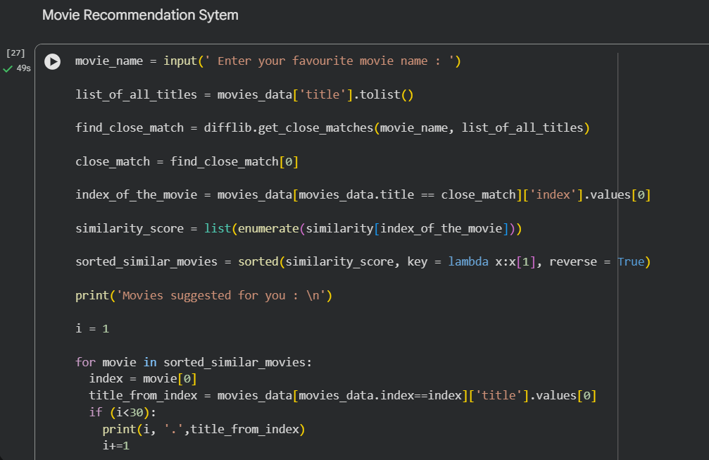

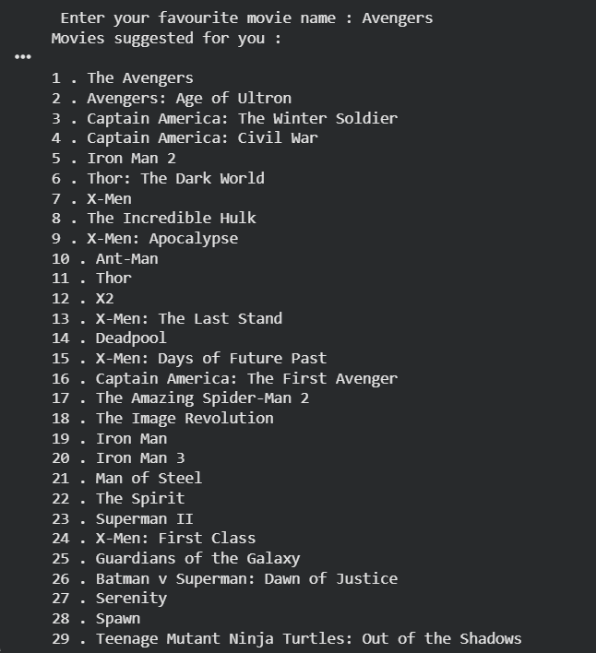

12. Advantages of the System
- Simple and efficient
- No user data required
- Works well with limited datasets
- Easy to understand and implement

13. Limitations
- Does not consider user preferences or ratings
- Recommendations are limited to content similarity
- Cold start problem for new movies with limited data

14. Future Enhancements
- Incorporate user ratings for collaborative filtering
- Develop a hybrid recommendation system
- Add a web-based user interface
- Improve accuracy using deep learning models

15. Conclusion
The Movie Recommendation System successfully demonstrates how machine learning techniques can be used to suggest relevant movies based on content similarity. The project highlights the importance of recommendation systems in modern applications and serves as a strong foundation for advanced recommendation models.

